**Aaron A. Kenna**

**CSC500**

**MOD3 CTA**

**3-9-2024**

**Critical Thinking Assignment**

**Part 1**

**meal_cost = float(input("Enter cost of meal:"))**

**gratuity = 0.18 * meal_cost**

**#print(gratuity)**

**print("Gratuity: $" + "{:.2f}".format(gratuity))**

**sales_tax = 0.07 * meal_cost**

**#print(sales_tax)**

**print("Sales Tax: $" + "{:.2f}".format(sales_tax))**

**total_cost = meal_cost + gratuity + sales_tax**

**#print(total_cost)**

**print("Total Cost: $" + "{:.2f}".format(total_cost))**

**#Output Total_Cost, Tax, Gratuity, Meal_Cost**

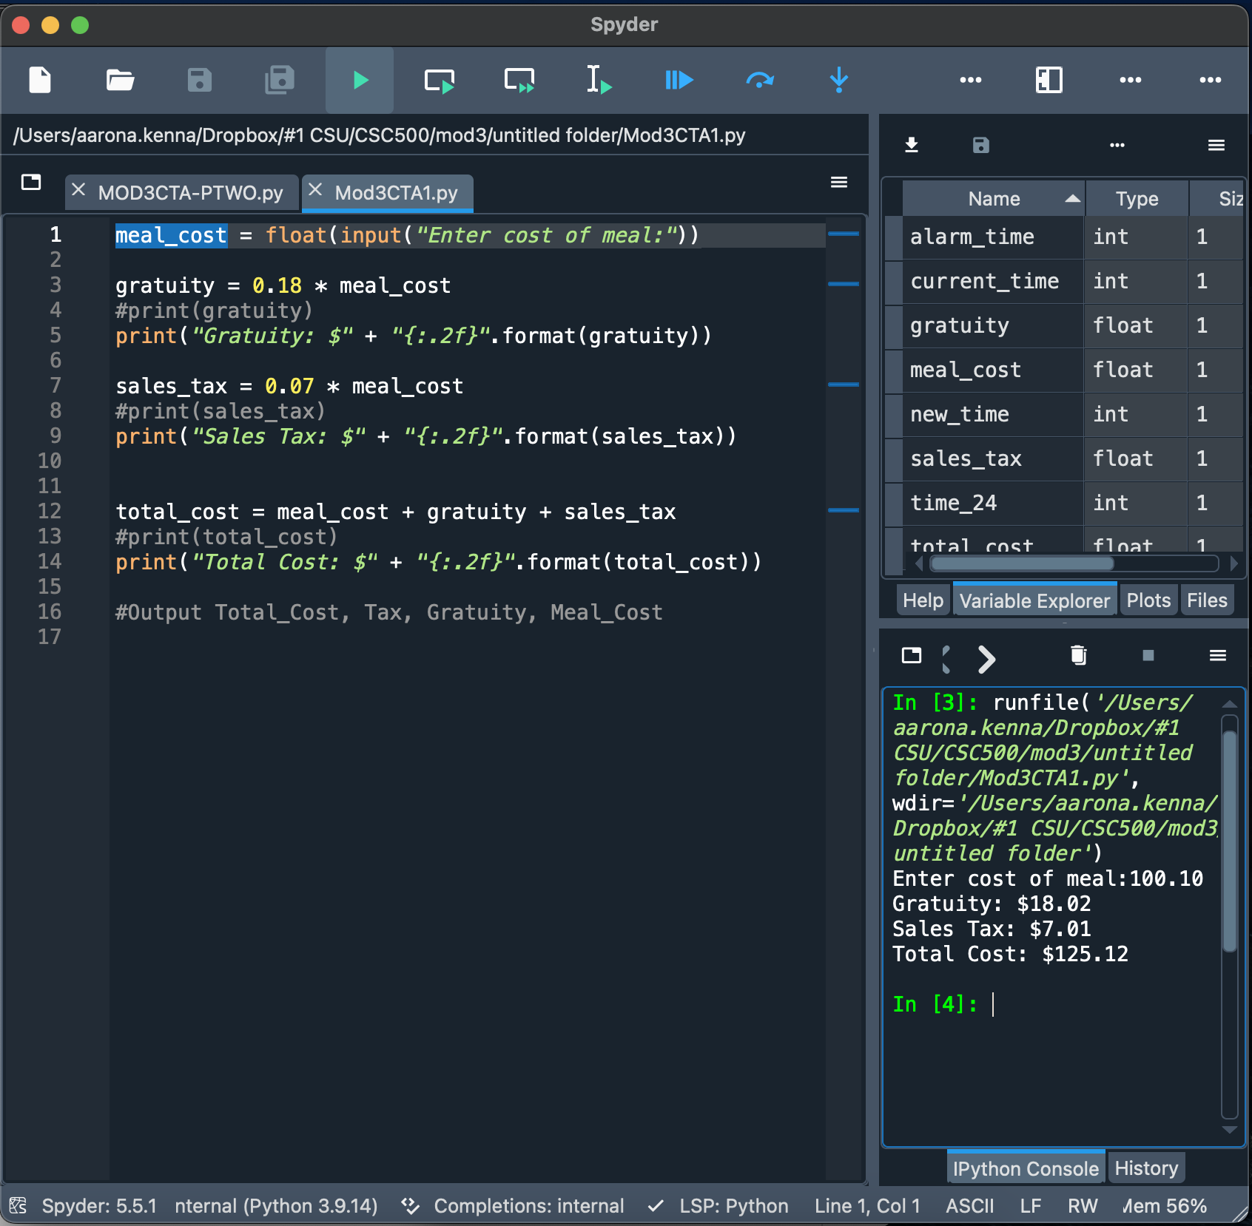

**Part 2**

**# Current time = 13**

**current_time = int(input('Enter current time in hours: '))**

**# alarm_length (50)**

**alarm_time = int(input('Enter alarm time:'))**

**new_time = current_time + alarm_time**

**time_24 = new_time % 24**

**print(time_24)**

